**Settlement**

**The Surge in Settlement 1760 - 1812**

Immediately following the Seven Years War, the northern settlement frontier of New England and New York was rapidly pushed north. For over 70 years the fear of raids along the vulnerable frontier, and the threat of depredations by French-allied First Nations, kept the British colonists from settling the upper reaches of the Connecticut River valley, the Champlain corridor, or even the northwesterly portions of the Merrimak.

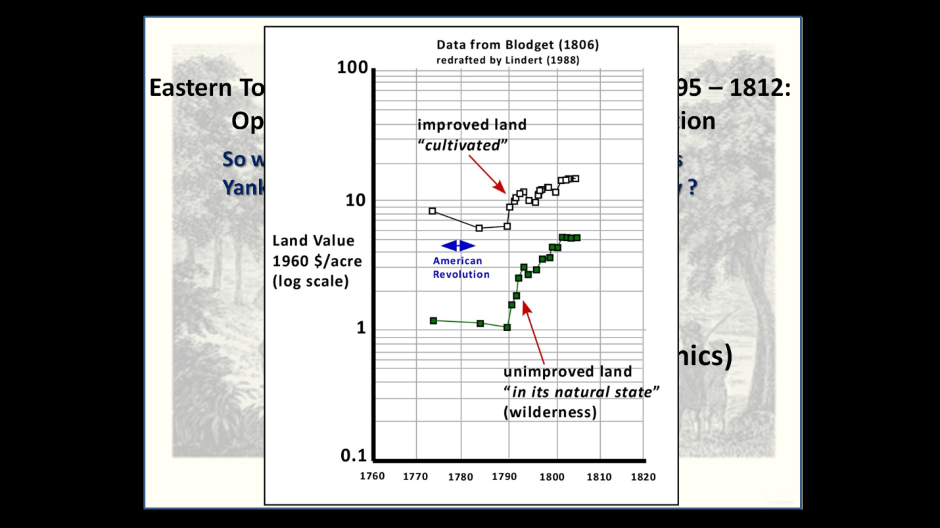In the intervening period from about 1712 to 1760, the population of New England grew, due to immigration and natural increase, from 132,000 to 450,000, and in New York from 28,000 to 117,100. By way of contrast, the population in New France only grew from 18,400 to 70,000. In the long settled parts of the British colonies arable, and still fertile land was becoming scarce and expensive, so when a permanent peace seemed secure, the urge to take up virgin lands was irresistible. However in addition to genuine population pressures, the second driver to settlement was simple avarice. The population was almost exclusively agrarian so there were few avenues to acquire wealth, but one means to do so was in land speculation. From farmers to merchants to Royal Governors, most everyone in the colonies seemed to have their fingers in land deals on some scale. The American Revolution reduced this land fever for a period of time, but once peace was again restored, speculation drove land prices skyward (see accompanying graph), and settlers were forced to go ever further into the wilderness to secure land on reasonable terms.

***Graph that shows dramatic increase in land prices, even in the wilderness, in New England following the American Revolution. Land fever was at a fever pitch and speculators drove the price of wild lands ever closer to cultivated lots! It was this mentality that fuelled keen interest in the land available in the Eastern Townships after 1792.***

A testament to the degree that land speculation gripped the British colonies is shown by the number of land grants or patents awarded for the territory that eventually became Vermont. Both the governors of New Hampshire and New York, in direct competition with one another, sold huge tracts of land (over 240 separate patents), mostly to speculators who had no true intention to clear and settle these parcels. Their goal was to sit on the lands until the settlement frontier reached them, then re-sale them at a significant profit. In this manner lands just south of Lake Memphremagog, forming what was called the Saint George patent, were sold by Governor William Tryon in November of 1774. In reality this area was not actually settled until 1794.

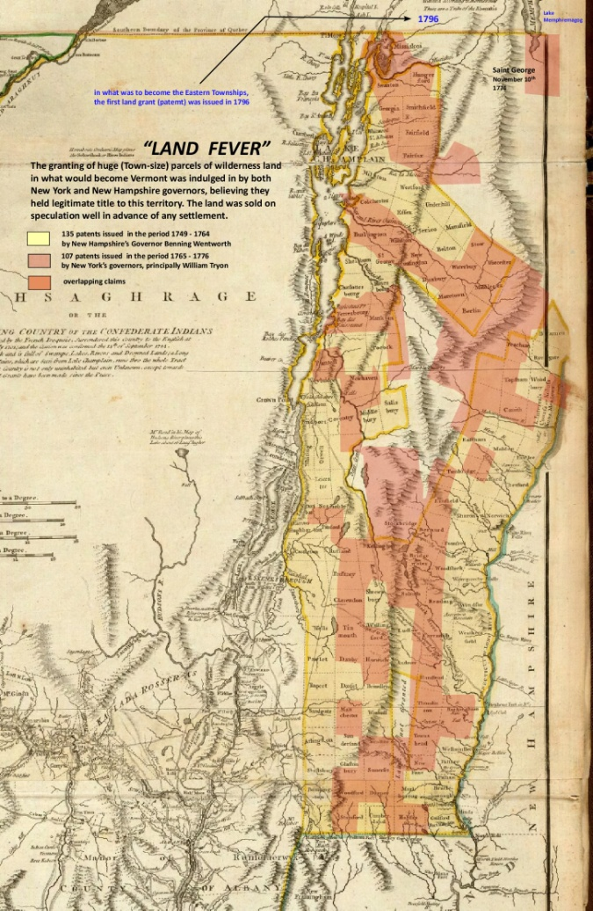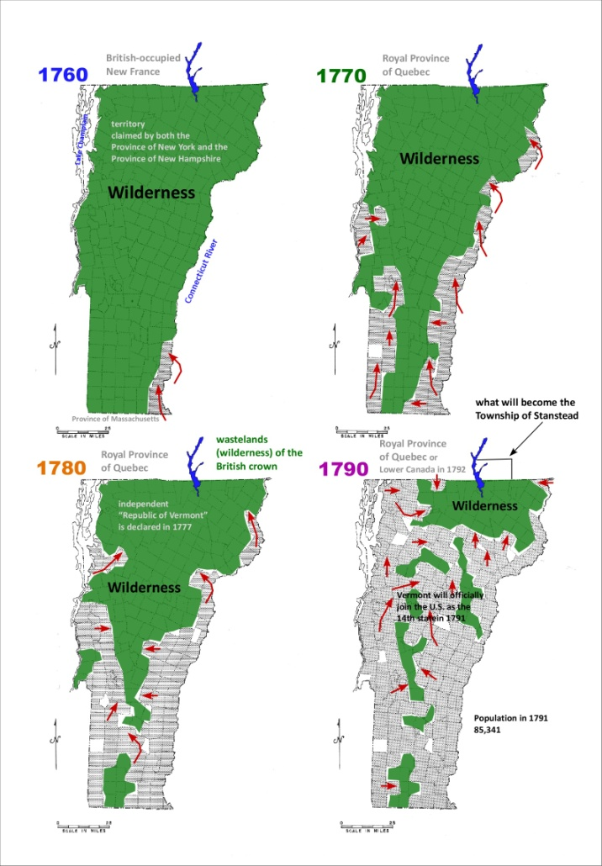***The territory of Vermont was vigorously sold off, in many places long before settlers had arrived. This was principally driven by speculation and greed. The map on the left modified after Holland (1768), shows the grants or patents issued by Governor Benning Wentworth of New Hampshire in yellow, those by various governors of New York (pink), and where these various competitive land grants overlapped, the shade is orange. Nevertheless in this area just to the south of Canada, real settlement was very rapid (series of 4 maps on the right) with Vermont attaining a population of 85,000 in just 3 decades.***

After the revolutionary war, with tens of thousands of Loyalists streaming north, the British authorities wanted the wastelands of the Crown, in what would become the Eastern Townships, preserved as wilderness. Loyalists who had settled in the Missisquoi Bay area were told to leave, and Loyalists were directed to settle further inland along the St Lawrence (what would become Upper Canada), the Gaspé, New Brunswick, and Nova Scotia…... anywhere, apparently, but near the inhabited French-speaking parts of Quebec.

The Loyalists had supported the Crown and they now had expectations. Pressure mounted on the British government to provide a separate English-majority jurisdiction which had some form of representative government, where English common law was enforced, and where land could be held in “fee and common soccage”. Westminister finally yielded, and in 1791 passed the rather obscurely-named “*Clergy Endowments (Canada) Act ”*, better known as the Constitutional Act. This act allowed land to be held outside of the seigneurial system, but no mention was made of allowing settlement in what would become the Eastern Townships.

Finally on February 9th of 1792 Lieutenant-Governor Allured Clarke published Terms of Settlement for the “wastelands of the crown” in what was now Lower Canada. The land rush in our region was on, and the Township of Stanstead (part of which would become Ogden) being adjacent to the border, was one of the new townships to feel this impact first.

The non-representative government in Quebec City scrambled to keep up with the new regulations. The external boundaries of over 90 new townships, approximately 10 miles by 10 miles in area, were surveyed and named, and a Land Committee was established. The British initially considered allowing individuals to apply for land grants, but it rapidly became apparent that the very limited and very new bureaucracy would be totally incapable of handling the thousands of demands for land. Instead the government opted to employ a settlement system similar to one long established in New England and New York (the so-called Town proprietor system), one that would seem quite familiar to the prospective Yankee immigrants. In Lower Canada it was called the Leader and Associate system, and by 1793 it was tweaked to work as follows.

* Groups of prospective settlers (associates), generally numbering between 40 to 60 heads of families, would choose one or two men to act as their leader in applying for and securing a land grant (typically a single township or part thereof). In reality, the Leader more commonly was somewhat self-appointed, and tried to round up the requisite number of settlers. The Leader tended to be a man of some influence, and at least some affluence.
* The Leader was required to pay for the internal division of the requested Township into 200 acre lots, build access roads as well as saw and grist mills, and to ensure the settlement of the Township.
* To compensate the Leader for the costs associated with his obligations, each associate would assign 4/5 of his allotted grant (often four or five 200 acre lots = 800 to 1000 acres), back to the Leader, only keeping the best 200 acre Lot to himself.
* The associates were obliged to take an oath of allegiance to the Crown, and were obligated to clear and cultivate __ acres within 5 years. Otherwise there was no cost to the associate to acquire the land.
* The Leader stood to amass a very sizeable land holding indeed. It looked good on paper, but the devil was in the details, and getting the associates to comply and hand over most of their granted land proved very problematic. The Leader then often had a long wait as the first settlers improved their lots, which in turn would drive up the value of the Leader’s adjacent undeveloped lots. At this point he could dispose of his lands at a considerable profit.

There remains a persistent notion that the Townships were initially populated by late Loyalists, Americans slow to realize the evils of republicanism, or slow to comprehend their latent loyalty to the British crown. This notion is completely false. Of course Loyalists did come to Quebec in the period 1777-1785, and some of these did become leaders of the settlement of the Townships, but the age of the average male settler and head of household coming into the area of Stanstead, Hatley, Compton and Barnston townships after 1792 was only 26. Of the segment of older settlers (less than __%) who could have participated in the Revolutionary War, far more fought on the side of the rebels than for the British.

So why would New Englanders cross to the north of the 45th parallel to settle in Canada? The answer lies largely in simple economics.

**1**. in Canada the settler would receive his standard 200 acres for free. In New England a typical unimproved lot of 65 to 100 acres in 1794 would have to be bought for $1.20/acre. The obligations in both cases for land clearing would be about the same. In short, more for less!

**2**. the standard/average northern New England farm size (including woodlots and undeveloped land) in 1800 would range from about 45 to 120 acres, adequate for subsidence farming and bringing a small surplus to market, however 200 acres in Canada offered a significantly greater potential to improve then sell or even sub-lease a portion of the land. At a minimum, a larger number of sons might share an inheritance. It must be remembered that the real commodity of interest in those days was the land itself, not agricultural produce. Land values in Vermont in the period 1791 to 1806 increased 170%, and similar increases would have been expected for the new Townships. A common strategy was for a settler to clear and improve his lot, enjoy the bounty of crops coming from un-exhausted virgin soils for a number of years, then sell his “improved” land at a premium.

**3**. as it was the state giving legal title to an associates land, the Leader did not wield the same power as a Town proprietor. This arrangement may have been seen as more egalitarian, and hence attractive, to the associates. A certain interdependence existed between leader and associates that was commonly absent in the Town proprietorship system.

The relative attractiveness of the opportunities of land in the Townships versus those in northern Vermont is nicely portrayed by the following. One population data set is from the Vermont census of 1810, the other from figures compiled by the Surveyor-General of Lower Canada Joseph Bouchette, published in 1815 but probably reflective of a slightly earlier period. It should be noted that for the territories under consideration, there would have been very little trans-border emigration either way during the War of 1812-1815 – only cattle smuggling! – so the difference in dates is probably not significant. The population of all the Towns in Vermont adjacent to the border from Missisquoi Bay to the Town of Holland was 4650, whereas on the Canadian side of the border from St. Armand to Barnston, for a similar spatial area, that figure is 7500. The land and topography on either side of the border is very similar, so the population differences in the early settlement period probably reflect the shrewd Yankee assessment, that land deals were better north of the 45o Line of Latitude.

How rapid was the influx of New Englanders to Ogden? For the smaller territory of what is now Ogden, it is not possible to tell, however for the Township of Stanstead we have some numbers and they indicate a very strong wave of immigration in the period 1800 to about 1810, after which it moderated, and then for a 3 year period ceased altogether during the War of 1812. During the period of heavy immigration, most of the settlers came from New Hampshire, Connecticut, Massachusetts and Vermont roughly in that order. Population growth in the Township after this period was almost entirely by natural increase minus some out migration.

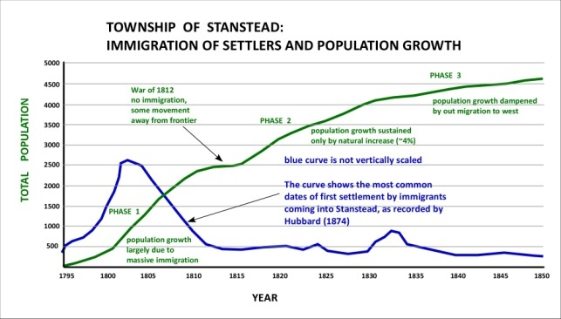

***Graph showing immigration into the Township of Stanstead***